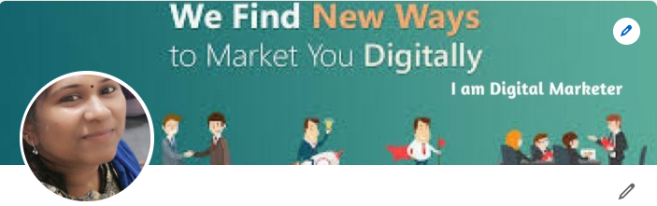**Hema Jaganathan – Senior Digital Marketing Consultant**

# **Email: hemajmca@gmail.com**

**Phone: +91 99413 31498 (Only WhatsApp call)**

**https://www.linkedin.com/in/hema-jaganathan-digital-transformation-marketing-and-business-development-consultant-35157030/**

**PROFESSIONAL EXPERIENCE:**

* + **Around 15+ years of experience in Performance Marketing and 6+ years in Market research and Data Analysis, Content, Email Marketing forB2C, B2B, Ecommerce and SAAS Products, Excellent in Organic traffic by SEO and SEM. Implementing Data Analysis for Optimizing Google PPC ads With Excellent ROI and Sales.**
  + **Excellent in Marketing for SAAS, Fashion brands, Edutech, B2B & B2C Ecommerce website.**
  + **Trained in Technologies like AWS, Google Analytics, Salesforce, Data Analyst, SQL, Python, R for Data Analysis and Visualization.**
  + **Excellent in SEO, Social media, Content and Email Marketing, PPC Campaign Manager Amazon/ Google Ads / Facebook.**
  + **Track and build data-driven improvements for ad targeting/ media spending.**
  + Prior experience in a similar role as well as experience building effective multi-channel marketing strategies, **including PPC, SEO, social media and other digital channels.**
  + Driving **SEO efforts**, analyzing potential keywords, and optimizing **organic traffic.**
  + Deep understanding of digital tools ( **Ex: Google analytics, ORM tools etc**)
  + Be responsible for the vision, strategy and execution of acquisition campaigns across all the digital platforms like **Facebook, Google, Instagram ,Twitter, Discord, LinkedIn etc**
  + Prior experience in **Content Marketing for social media platforms and corporate websites.**
  + Strategizing and developing a **360 degree overall marketing plan**.
  + Deep knowledge of online marketing and thorough **familiarity with the Ecommerce B2B, B2C.**
  + Planning and execution of **high-performing digital marketing campaigns**. This involves competition monitoring, creating and managing campaigns, preparing reports or driving & sharing insights.
  + Launching optimised online **adverts through Google AdWords, Facebook, LinkedIn, YouTube** etc.
  + Report on ad/ media performance including **CPL, CPA, ROI and ROAS** on a weekly, monthly and quarterly basis.
  + Setup end to end **analytics dashboard** for every marketing activity
  + Experience in **direct marketing: SMS and email campaigns**
  + Experience with analytics tools such as **Google Analytics, SEMRush, Google Data studio**
  + Excellent team management, verbal and written **communication skills**
  + Execute **full funnel digital marketing campaigns** including strategy, ad creation, bidding, budgeting, reporting.

**HIGHLY EFFECTIVE DIGITAL MARKETING & E-COMMERCE PROJECTS:**

Goal driven professional whose accomplishments reflect outstanding marketing instincts, proven track record of productivity and diversity. Demonstrated strengths in managing people and projects for B2B & B2C companies.

**Key Knowledge Areas:**

* Digital Marketing & Content Strategy - E-Commerce Project Management
* SEO and Social Media Marketing - Web Analytics & Reporting
* **Email Marketing** - Web Content Management & Publishing
* CRM implementation, Management - **Marketing Data Analytics, Python, SQL**
* **Google Analytics, Adobe Analytics - Tableau, Microsoft Power BI**

**Expertise in:**

E- mail Marketing, Lead Generation, business research, Market research, Brand Awareness, Online Reputation Management, Email Newsletter creation, Marketing Automation with CRM (Infusion soft, Sales force, Hub spot), Project Management, Account Management, Digital strategy, Web Analytics, Tableau, Video production.

Data Analytics, python, R, SAS, SQL, Tableau, Google, Adobe Analytics for Analysis of the customer journey.

# **Honors & Awards**

**BEST PERFORMER • Blackstone Group of companies • Aug 2008**

# Awarded for BEST PERFORMER on the year Aug 2007, Dec 2008, and Jan 2013 and Effective Team player Award for best performer of the team.

**STAR PERFORMER • Filmyfy • Aug 2016**

# Achieved the STAR PERFORMER award in handling YOUTUBE/SITE/APP reach project, with campaigns and SEO made the site and App to reach more..

**MILE STONE PERFORMER • U.S TOP FORTUNE 500 • Dec 2010**

# Got a certification for MILE STONE in US survey project and getting appreciation e-mail from the client of Blackstone for the month of December 2010

**Core Strengths & Responsibilities include**:

**Web development:** Design and develop nearly 20+ website by using HTML, HTML5, CSS, JavaScript, PHP, Java,

Angular JS, CMS, SQL

**Digital Analytics** — Using Google Analytics I produce website performance reports and dashboards (Google Data Studio) to monitor the effectiveness of all digital marketing campaigns.

Fluency in Microsoft Office suite (**Outlook, Excel, Word, PowerPoint, etc**.)

**Google Tag Management** — Using Google Tag Manager I perform and manage the implementation and governance of all tagging activity.

**SEO** — Utilized SEO best practices including keyword/topic research, targeted content creation, onsite optimization, link building, keyword rankings, organic traffic, and conversion rates.

**SEM** - Search Engine Marketing, PPC, Display Ads, Search Ads, Remarketing Ads, Conversion optimization, quality rate.

**SMO, SMM** - Social Media Optimization - Implementing Social Media Strategies for the Products using Best Channels like

Facebook, Twitter, LinkedIn, Google plus, Stumble upon, Reddit, etc. Paid ads in Facebook, Twitter, LinkedIn, etc.…

**Paid campaigns** primarily focusing on google AdWords which will include:

* Google Ads, Facebook Ads
* Youtube Ads
* Google Search bar ads
* Re-marketing / Display Advertising
* Campaign Set up
* Client Retention

# **Education:**



**Anna University**

Master of Computer Applications

-

MCA, Master of computer Applications (MCA), First class

**University of Madras**

Bachelor of Computer Applications

**Skills**

**Tools**:

Google Search Console, Google Analytics, Adobe analytics (Omniture), Core Metrics, AdWords,

Mailchimp Email tool, Moz, SEMRush, WordPress, Search Metrics, Survey Monkey, ReadyTalk webinar tool,

Hootsuite, SproutSocial, Domo re

porting, Raven, ScreamingFrog 10, Salesforce email cloud, Hubspot Hub

Asp.net,

HTML,

CSS, SQL,

JavaScript, XML, CSS

, PHP

Microsoft Excel, Microsoft Word, Microsoft Powerpoint.

Advanced formulas and chart customization.

**Freelancer: Digital Marketing Consultant – SaaS, Ecommerce, Edutech, B2C,B2B EdcutechEcommerce)** **(B2C,B2B, Ecommerce)**

**Digital Marketing, PPC, SMO & SEO specialist May 2019 – Till now**

**Handled nearly 10+ clients from Singapore, US, UK and India clients for Edu tech, SaaS, Ecommerce B2b & B2C**

* Creating and executing a strong performance marketing strategy & execution plan.
* **Introduced retargeting campaigns including individualized discounts on high ticket items, improving total ROAS for these products.**
* Performed SEO and quality analysis of all websites page and content to improve the average google rank for the top 20
* Be responsible for the vision, strategy and execution of acquisition campaigns across all the digital platforms like Facebook, Google, Instagram , Twitter etc
* Hands on experience and deep platform understanding of amazon, Flipkart and other seller platforms
* Managing budgets and campaigns across all digital channels to drive strong return on investment and efficient CAC
* Ensuring successful planning, execution, optimization for key traffic KPIs via paid, organic & own media channels including websites
* Execute full funnel digital marketing campaigns including strategy, ad creation, bidding, budgeting, optimization, and reporting
* Forecast, monitor and achieve customer acquisition, conversion goals via paid channels
* Acquire new customers with efficient customer acquisition cost in line with budgets and targets
* Work closely with the Product team on conversion optimization and the Analytics team to draw actionable insights
* Collaborate with Design & Content Marketing teams to develop relevant content and creatives for social media campaigns
* Manage all internal stakeholders and external third parties, digital agencies and service providers
* Develop a strong reporting framework, analytics, and ROI tracking for all our platforms
* Forecast monthly, quarterly, annual acquisition numbers and costs
* Working closely with the management to share funnel conversion improvement ideas, feedback & present results.

**Achievements on my work for clients:**

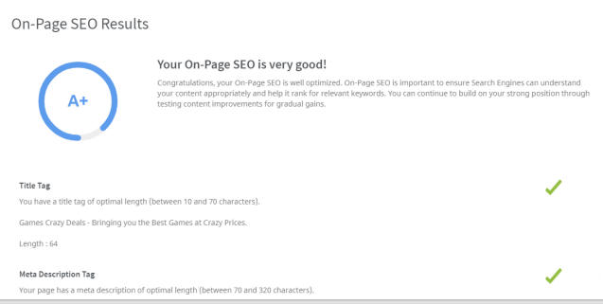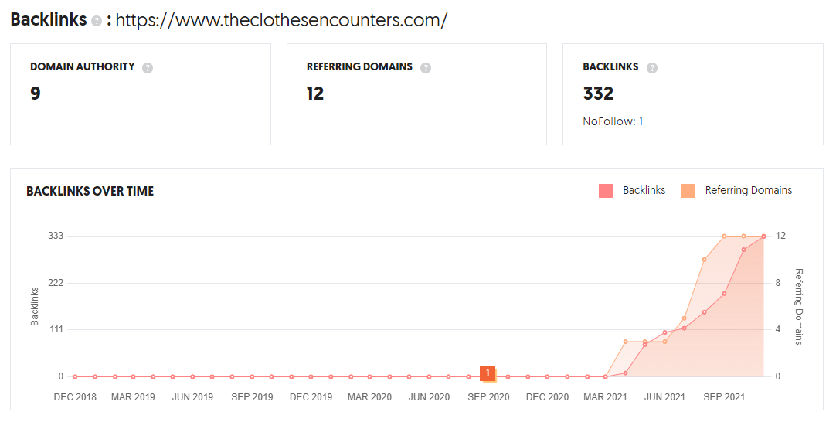

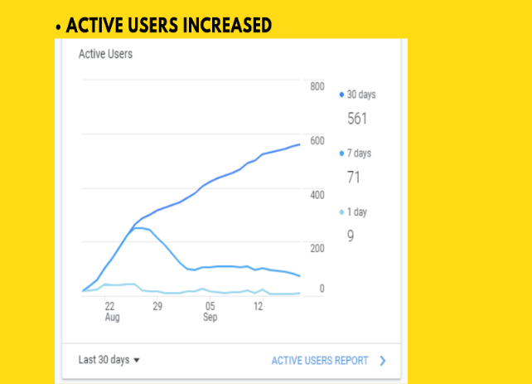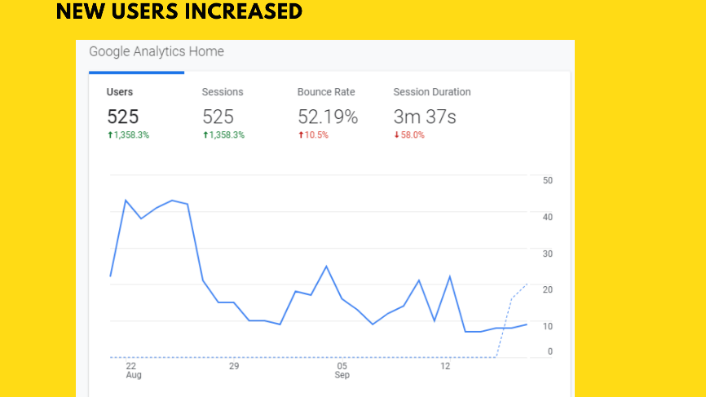

* 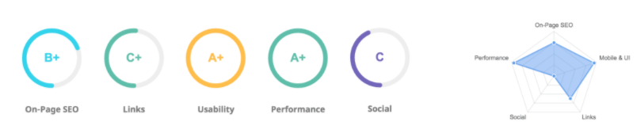

## **Digital Marketing Manager** **(B2C,B2B, Ecommerce)** **Jan 2019 – May 2019**



**Boltz Engineering Pvt Ltd, Chennai**

* SEO Strategy – Building SEO strategy for Asian (ANZ) & Europe (FR,IT,ES) countries ecommerce websites, special deals strategy, high profile product launches, landing pages, etc.
* SEO Optimization: On page& Off page optimization for Lenovo website for AP/EMEA countries on all parameters (Meta info., page content, images, links, speed, HTML, JS, CSS ), sitemap maintenance, PR, Social promotion support (content curation, SEO check), SEM campaign support (KR, ad performance evaluation), Blog content curation for major launch/sales
* Keyword Research (MOZ/SEMRush/SearchMetrics Tools) – Using Google keywords planner, Moz keyword explorer tools to narrow down targeted keywords, long tail phrases, SEMRush to track competition keywords for all launches/campaigns
* Marketing Channel Collaboration – Seamless integration with other marketing channels like Brand, Social Media, Paid Search, Email, Display teams for major campaigns, product launches, projects to achieve objectives. Manage Editorial calendar for weekly/monthly content promotions
* Google Search Console Management - For traffic performance, WoW & YoY comparison, Clicks, Imp. CTR, Position, country traffic, image & video performance, crawl errors, html improvements, Meta fixes, mobile speed analysis
* Web Analytics – Site performance analysis via Adobe analytics (omniture) using workspace metrics reporting tool on campaign performance (Visits, revenue), bounce rate, page speed, business unit analysis. A/B testing for landing page revamp projects
* Monthly Reporting - Monthly SEO dashboard/ppt on SEO project status, Quarterly performance review, campaign support measures & plans, future project plans and presenting to Stakeholders
* Resource Management – Managing SEO specialists on SEO strategy and implementation. Co-coordinating with other Country Managers, Web Merchandising team, Country Marketing team, SEO dev team, quality team, CMS team, analytics on SEO related projects.

## **Digital Strategist (Edutech)** **June** **2017** – **Dec** **2018**



**NPTEL**, **Chennai**

* Digital Marketing: Participate and contributing to BU digital strategy. Implement projects and deliver digital results Partner with Performance marketing to (plan) track and deliver digital campaigns results
* Digital Analytics: Define and developing KPIs and dashboards for Business Unit's website launches, campaigns and web initiatives Enable Marketing teams to adopt, operationalize and succeed with analytics
* Ensuring adherence to IBM business guidelines Social Media Marketing Work with marketing to maximize opportunity with social media tools like blogs, Facebook, Twitter etc.,
* Working with different teams like the Campaign Managers, Portfolio team, Planning team, Events team, IMTs on campaign planning & Execution
* Launch web pages for Global Business Services BU with greater UI experience to customers adhering to latest design standards. Mobile friendly optimization for web pages.
* Managing multiple stakeholder expectations and cross- functional projects Search Optimization Identify search optimization opportunities and engineer strategies SEO and page optimization audits

## **Team Manager – Web development and Digital Marketing** **Mar 2013 – June 2017**



**Raj Television Network Ltd, Chennai**

* Worked Manager for Web Marketing Operations handling a team (developers, UI) to manage/redesign the websites/micro site/blogs to promote Life sciences software products
* Website Content Management: Complete ownership of the web content (WordPress/Joomla), publishing workflow, Content quality & SEO review and sign off process, Product assets management (white papers, webinars, downloadable articles, press releases, event calendar publishing). Web leads management
* E-Commerce Operations & Email Campaigns: Online Orders, payment integration, registration tracking/reporting for all the company’s event promotions (SUC, RAUM, DIA, IDMP, etc.,). Planning, Targeting, Scheduling and Designing for all domains using Email Management Tool (Review & Analysis of Email performances with monthly dashboard showcasing all metrics)
* Search Engine Optimization & Social: Created/Process documents for SEO Process for the company aligning with goals (KPIs). Handling webmaster tools (Google, Bing). White-hat SEO methods (both on-page, off-page) for all company websites in improving overall ranking. Managing Facebook, Twitter, LinkedIn, YouTube accounts to promote the brand and all Company Events, continuous improvement in social sharing, connections tweets & retweets. Continual revival of SMM process/SOV to match the current trends.
* Digital marketing campaigns: Planning and budgetary control for ATL, GTM campaigns for events, collaborating with Product Marketing Managers, Events Team, CRM team (Salesforce), Market Research, Market Intelligence team, Field Operations, Pre-Sales teams. Mobile optimization via responsive design strategy, Mobile search enhancements, ASO (App Store Optimization) measures.
* Web Analytics: Building and customizing Google Analytics and Tag Manager implementations Tracking websites and mobile apps, and visualizing data for a variety of clients.

## **Data Analyst – Market Research** **Dec 2006 – Feb 2013**



**Data Prompt International Ltd, Chennai**

* E-Commerce Operations: End-to-End Project Management starts from Product Development till Configure & Buying operation which involves all process groups (Initiation till Closure). Creating various surveys for various products and analyses the data for product launch.
* Experience in Market Research with emphasis on quantitative research and or survey design. Healthcare and life sciences focus strongly preferred.
* SEO & Content Management: SEO implementation for product pages via on page and off page optimization techniques. Analysis of search results, performance metrics, enhancement techniques.
* SEM Campaigns: Participated in Paid campaigns for google for various product launches by targeting ideal keywords to be on par with competition like HP, Asus, Acer etc covering Asian market
* Web Analytics with exposure in Google Analytics (GTM) & Omniture tools, Traffic metrics and improvement projects, competitive analysis, portal improvement planning, feature testing, researching, reviewing & reporting on competitors & rival products.
* Planning and Participating in Social Media campaign strategy for various product promotions. Analysis, Reporting & Enhancement methodologies for all digital campaigns.

**Other Work Experiences:**

Aptech InfoTech., (Trainer) July ’05 - Dec ’06

CSC., (Trainer) Sep ’04 - July ‘05

**Certifications:**

**Prince2 ® Practitioner • AXELOS Global Best Practice,** Dec 2016 - Dec 2021

 **Data Scientist - Simplilearn,** Feb 2019

** Digital skills, Digital Marketing - Accenture**

**Google Digital Garage,** **Google Analytics, Google AdWords, Google Marketing Platform, Google My Business Basics**



**Bing Ads Accreditation• Microsoft**







**YouTube Certifications • YouTube**

 **Yandex Direct, Yandex Metrica • Yandex**



**Twitter Video Ad Badge • Twitter**



**Klipfolio Expert, Klipfolio Partner • Klipfolio**

 **Inbound Marketing, Email Marketing, Content marketing, Social Media Strategy Certifications• Hubspot**

 **Keyword Research, PPC, SEO, SMM fundamentals, Social Media Toolkit, On Page &Technical SEO • SEMrush**

 **Mobile in DoubleClick Bid Manager Basics,** [**Dig into programmatic and Ad Exchange**](https://certificationanswers.xyz/dig-into-programmatic-and-ad-exchange-assessment-answers/)**,** [**Search Campaign Management**](https://certificationanswers.xyz/doubleclick-search-campaign-management-assessment-answers/) **• Google**

 **Certified Online marketing manager, Top 10 Social Media Management Tools,**

**AMA Professional Certified Marketer in Digital Marketing • LinkedIn** Aug 2018 – Present.